Reading Bingo
read on your couch | read to a pet | read your favorite book | read in bed | read wearing a hat
read by the window | read a graphic novel or comic book | read on Friday | read your friend’s favorite book | read in a fort you made
read a book about animals | read outside | Free  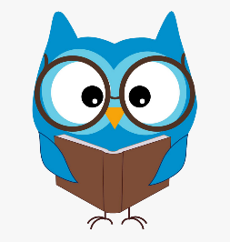 | read a fairy tale | read in your pajamas
read for 30 minutes | read a nonfiction book | read to a stuffed animal | read in the grass | read with a flashlight
read to a family member | read a silly book | read under a table | read for 20 minutes | read out loud

